Week 3 Lab Task
Scanning & Enumeration
NIAI NAVTTC — Certified Ethical Hacker (CEH) Course
⚠ Important: All tasks must be performed only in your isolated virtual lab environment. Never test on real networks or systems without explicit written permission.

Task: Conduct a comprehensive network scan to identify all active hosts and services. Perform vulnerability scanning on identified hosts. Perform active enumeration on a Windows-based network to identify Active Directory users, groups, and systems.

Step 1 — Set Up Your Target VM
▶ Download and Import Metasploitable 2
Go to: sourceforge.net/projects/metasploitable/
Download the Metasploitable 2 zip file and extract it.
In VirtualBox: File → Import Appliance, or just add the .vmdk as a new VM.
Set BOTH Kali and Metasploitable to the same 'Host-Only Adapter' network so they can talk to each other.
Start Metasploitable. Login: msfadmin / msfadmin
Run ifconfig to find its IP address (e.g. 192.168.56.101). Note this IP — you will use it in all commands below.
Step 2 — Network Scanning with Nmap
▶ Ping Sweep — Find Live Hosts
nmap -sn 192.168.56.0/24
This lists all devices that are online on your host-only network.
▶ Full Port Scan with Service Detection
nmap -sV -p- 192.168.56.101
-sV detects service versions. -p- scans all 65535 ports.
▶ OS Detection
nmap -O 192.168.56.101
▶ Vulnerability Scan with Nmap Scripts
nmap --script vuln 192.168.56.101
This runs Nmap's built-in vulnerability detection scripts against the target.
Step 3 — Enumeration
▶ Enumerate Windows / Active Directory (if Windows VM is available)
enum4linux -a 192.168.56.101
This tool extracts users, groups, shares, and policies from Windows/Samba targets.
▶ SMB Enumeration
nmap --script smb-enum-users 192.168.56.101
nmap --script smb-enum-shares 192.168.56.101
▶ Additional Enumeration with Nmap Scripts
nmap --script=nbstat 192.168.56.101 # NetBIOS info
nmap --script=snmp-info 192.168.56.101 # SNMP info
nmap --script=dns-brute 192.168.56.101 # DNS brute force
Step 4 — Document Your Findings
▶ Write a Scan Report
Record the following for each host found:
- IP address and hostname
Field | Details
IP Address | 192.168.1.17
Hostname | metasploitable.localdomain
Alternate Hostname | irc.Metasploitable.LAN
MAC Address | 08:00:27:DD:94:38
Vendor | Oracle VirtualBox virtual NIC

Nmap (Network Mapper) is a free, open-source tool used for network discovery and security auditing.
-sn flag performs a ping sweep — it sends ICMP echo requests to all hosts in a subnet to find which ones are alive, without doing any port scanning.

-sn flag performs a ping sweep — it sends ICMP echo requests to all hosts in a subnet to find which ones are alive, without doing any port scanning.

- Open ports and services running
A full port scan with service version detection was performed.
Nmap's -sV flag probes open ports to determine the exact service and version running.
The -p- flag tells Nmap to scan all 65535 ports instead of just the default top 1000.
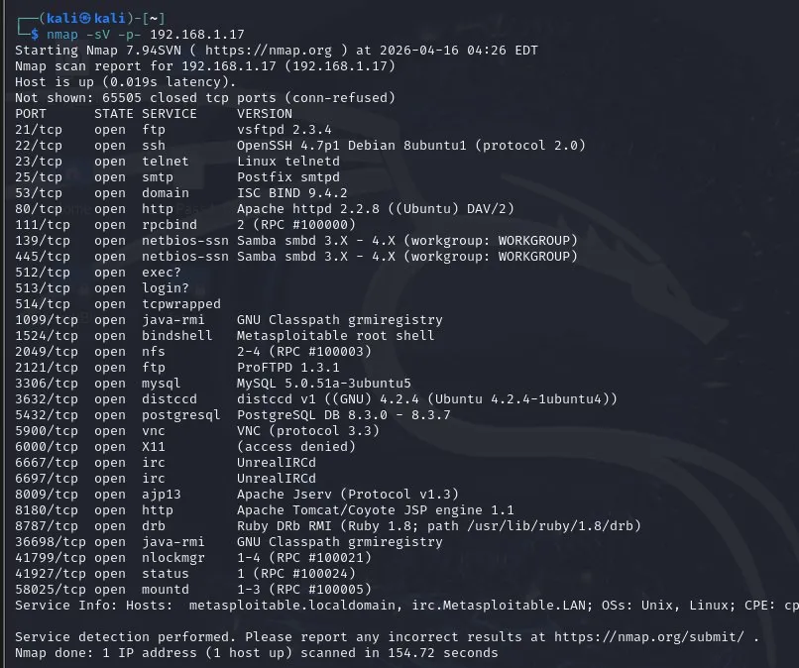

- Operating system detected
OS detection was performed using Nmap's -O flag, which analyzes TCP/IP stack fingerprinting to identify the target's operating system. It sends specially crafted packets and compares the responses against a database of known OS signatures.
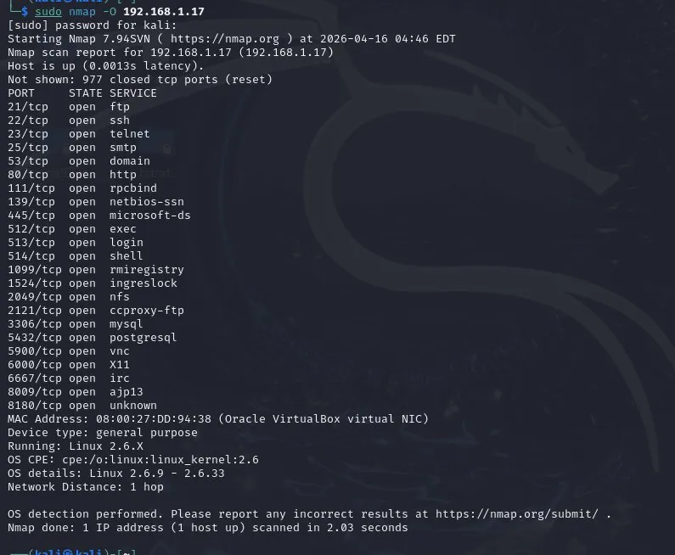

- Any vulnerabilities flagged by Nmap
Nmap's --script vuln flag runs the Nmap Scripting Engine (NSE) vulnerability detection scripts against the target.
NSE allows Nmap to execute Lua scripts that check for known CVEs, misconfigurations, and exploitable services automatically.
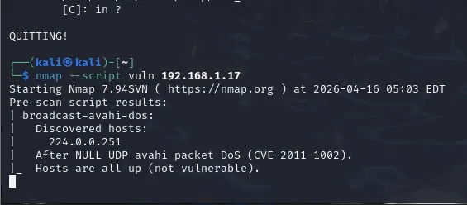
- Any users/shares found during enumeration
Enumeration was performed using enum4linux and Nmap SMB scripts. Enumeration means actively querying a target to extract detailed information such as usernames, group memberships, shared folders, and security policies.

enum4linux -a — performs all enumeration checks including users, groups, shares, password policies, and OS info via SMB/NetBIOS
--script smb-enum-users — uses NSE to query SMB for a list of user accounts
--script smb-enum-shares — uses NSE to list all SMB shared folders and their access permissions
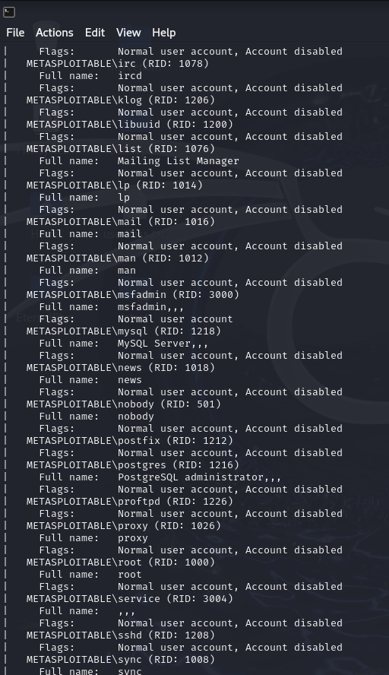
🎯 Goal: A complete scan report listing active hosts, open ports, running services, OS info, and enumerated users/shares — with potential vulnerabilities identified.

